1. Project Title: Web Platform for Carbon Footprint Monitoring and Sustainability Analytics
2. Project Statement and Outcomes:
Most individuals have no reliable way to quantify their daily environmental impact — the carbon emitted by their commutes, electricity consumption, diet choices, and consumer purchases adds up invisibly. Without a structured tracking tool that converts everyday behaviors into measurable CO₂ equivalents, personal sustainability goals remain vague and unactionable. This project builds a full-stack Java carbon footprint tracking platform using Spring Boot and React.js where users log daily activities across transport, electricity, food, and shopping categories. The backend applies configurable rule-based emission formulas (kg CO₂e per unit) sourced from IPCC and EPA datasets, calculates weekly and monthly footprint totals by category, generates personalized reduction recommendations based on the highest-impact activities, and supports user-defined sustainability goals with milestone tracking.
The deliverable is a complete personal carbon tracking web application with a Spring Boot REST API backend and an interactive React.js sustainability dashboard. Users log activities, view real-time CO₂ calculations, track progress against personal reduction goals, and receive tailored weekly insights. The dashboard presents rich visualizations: category-wise footprint breakdown (Recharts pie chart), weekly trend line chart, month-over-month comparison, and a peer benchmarking view comparing the user's footprint against platform averages. A community leaderboard rewards consistent low-footprint users with badges and rankings, creating positive social reinforcement. Businesses or institutions can access an organizational dashboard aggregating employee footprints for corporate sustainability reporting.
3. Modules to be Implemented:
- User Profiles, Activity Logging Schema & Emission Calculation Engine
- Analytics Engine, Reduction Recommendations & Goal Tracking
- React.js Sustainability Dashboard, Charts & Community Leaderboard
- System Integration, Testing & Project Finalization
4. Week-wise Module Implementation and High-Level Requirements:
Weeks 1-2: User Profiles, Activity Logging Schema & Emission Calculation Engine
- Design PostgreSQL schema for users, activity_logs (category, activity_type, quantity, unit, log_date), emission_factors (configurable kg CO₂e per unit per activity type), goals, and badges with JPA entities and Flyway migrations.
- Implement Spring Security 6 JWT authentication with optional Google OAuth2 login for quick onboarding; build user profile management API with sustainability preference settings.
- Build activity logging REST APIs for four categories: transport (car km, flights, public transit), electricity (kWh consumed, energy source), food (meal type, servings), and shopping (product category, spend amount).
- Implement the emission calculation engine: for each logged activity, multiply quantity by the configured emission factor for that activity type/unit, returning a kg CO₂e value stored per log entry.
- Write JUnit 5 unit tests for emission calculations across all categories with boundary cases (zero quantity, maximum values, unknown activity types) and parameterized tests for emission factor correctness.
Weeks 3-4: Analytics Engine, Reduction Recommendations & Goal Tracking
- Build a daily/weekly/monthly footprint aggregation engine using JPA JPQL aggregate queries grouped by category and date range, with results cached in Redis for sub-100ms dashboard load times.
- Implement a personalized reduction recommendation engine: analyze the user's top 3 highest-emission activities over the last 30 days and generate specific, actionable reduction tips mapped to each activity type.
- Build a goal management system: users set a target footprint reduction percentage over a configurable period; the system calculates weekly progress, projects whether the goal is on-track, and sends encouragement or correction alerts.
- Implement a peer benchmarking module: calculate anonymous platform-wide averages per category and present each user's relative standing (percentile) against the user base to motivate improvement.
- Build a badge and achievement engine using Spring events: award badges for milestones (7-day streak, first goal achieved, carbon reduction of 10/25/50 kg CO₂e) and persist them to the user's profile.
Weeks 5-6: React.js Sustainability Dashboard, Charts & Community Leaderboard
- Build a React.js activity logging interface with: category tabs, activity type dropdowns, quantity inputs with unit labels, and a quick-log carousel for frequently logged activities.
- Implement a personal sustainability dashboard in React with: today's footprint summary, Recharts category breakdown pie chart, weekly trend line chart (current week vs. last week), and monthly cumulative progress bar.
- Build a goal tracking widget in React showing current footprint vs. goal target, daily reduction required to stay on track, and a timeline chart projecting future footprint based on recent trend.
- Develop a community leaderboard in React displaying top 50 lowest-footprint users (anonymized by username) with their badge collection, category strengths, and a 'follow their habits' tips section.
- Implement an organizational/corporate dashboard in React aggregating footprints of all users in a registered organization, showing team-wide emissions by category, month-over-month trends, and a per-employee comparison table for CSR reporting.
Weeks 7-8: System Integration, Testing & Project Finalization
- Conduct end-to-end integration testing across all modules — activity logging → emission calculation → analytics aggregation → recommendation engine → React dashboard → leaderboard — and resolve any cross-module compatibility issues and edge-case failures.
- Perform load and stress testing on Spring Boot REST APIs using Apache JMeter or k6; conduct cross-browser UI validation on Chrome, Firefox, and Edge; address performance bottlenecks and implement enhancements from peer and mentor review.
- Refine the user experience based on testing feedback: improve interface clarity, add contextual help and input validations, ensure full responsiveness on mobile and tablet devices, and polish transitions and error states across all React components.
- Prepare comprehensive project documentation covering system architecture, entity-relationship diagrams, API reference (Swagger/OpenAPI via springdoc-openapi), deployment guide (Docker Compose), database migration scripts (Flyway), and known limitations.
- Develop the final project presentation (PPT) covering problem statement, proposed solution, architecture, key features, technology stack, results, challenges, and future scope — and rehearse the full end-to-end demo for a smooth, confident delivery.
5. Flow chart:
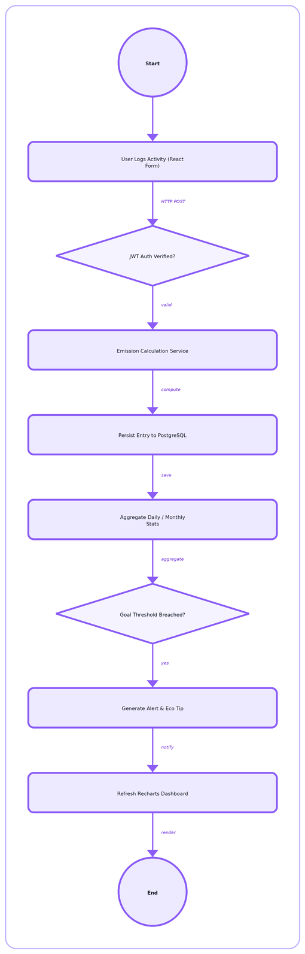

6. Sample Dashboard:
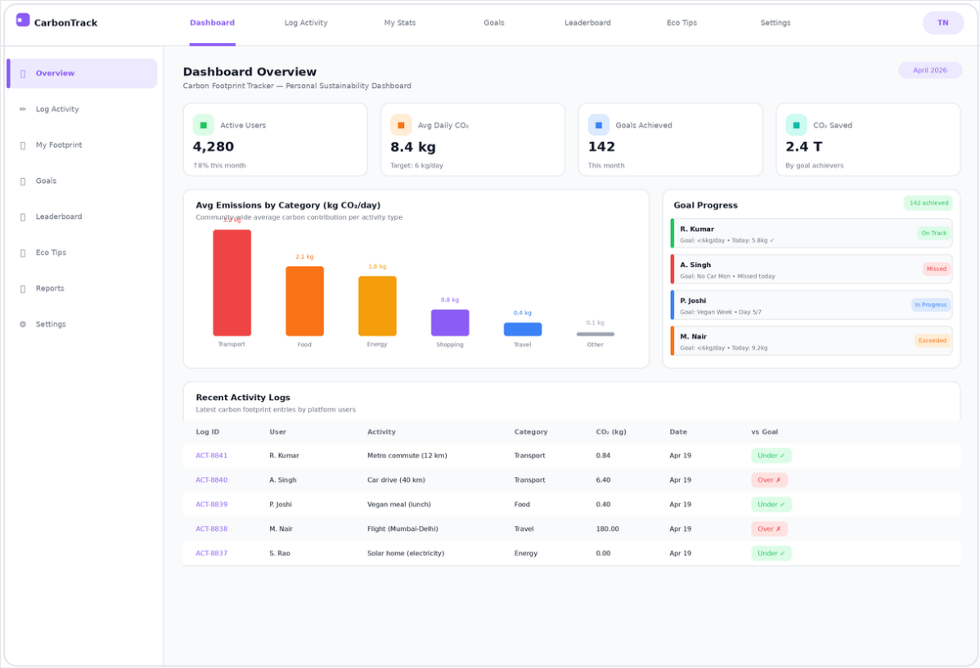

Frontend : react js
Backend : spring boot ,java
Database: mysql
cors

